Session 2
Q1.

Create a new React app using Create React App, open App.js, and replace its content to display a JSX heading that says 'Welcome to React JSX!'.
Ans.
Ans.
npx-create-react app hello
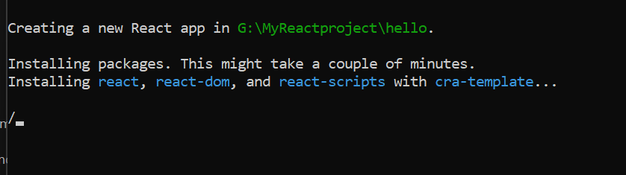
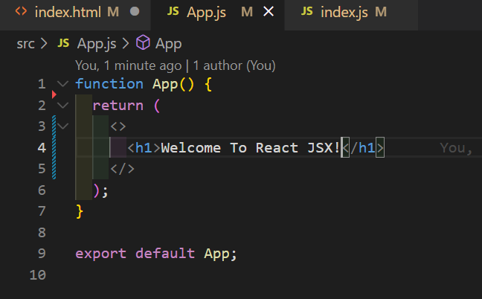
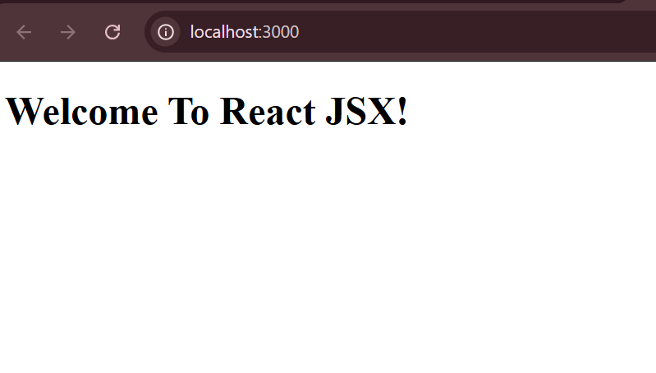

2.
Write a functional component called UserGreeting that takes a username prop and displays 'Hello, {username}!' using JSX. Render it in App.js with your own name as the username.
Ans.

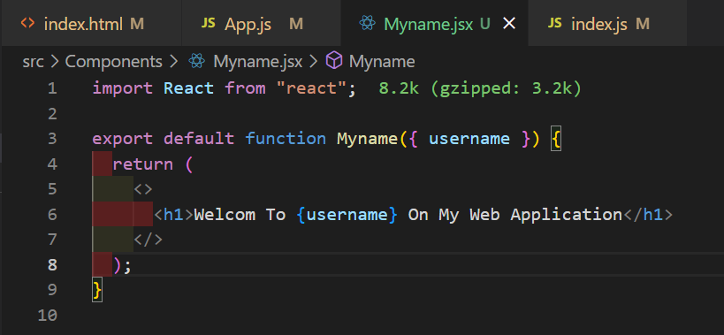

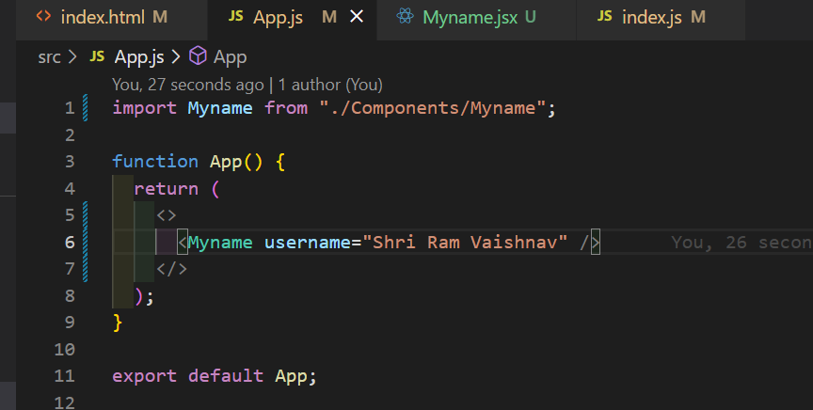

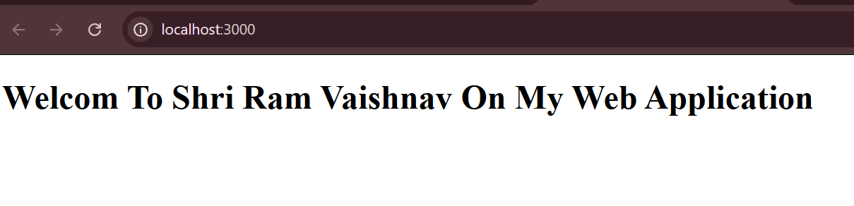
3.
Convert the UserGreeting functional component into a class component named UserGreetingClass that also takes a username prop and displays the same greeting. Render both versions (functional and class) in App.js to compare.

Ans.
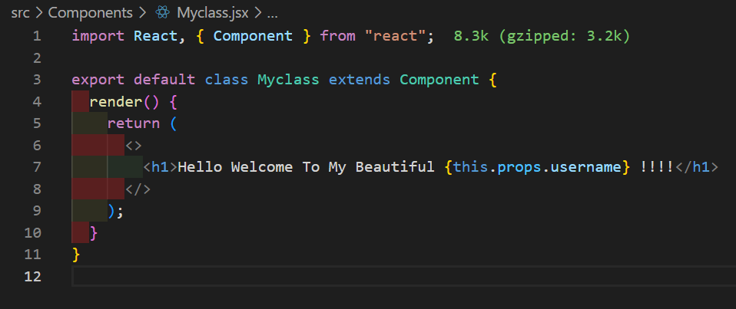
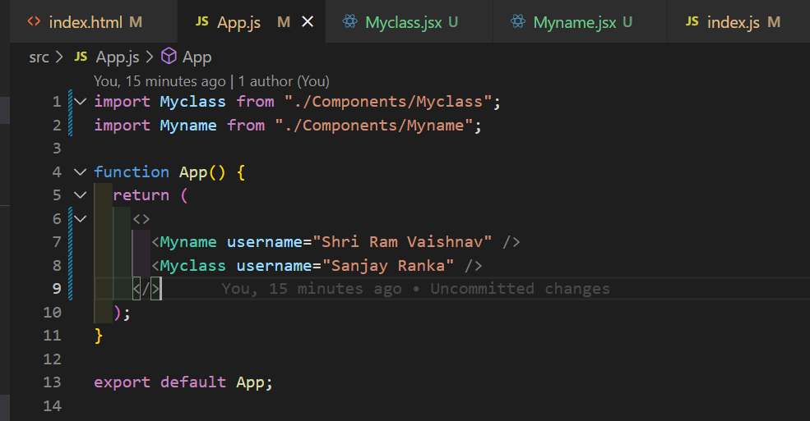
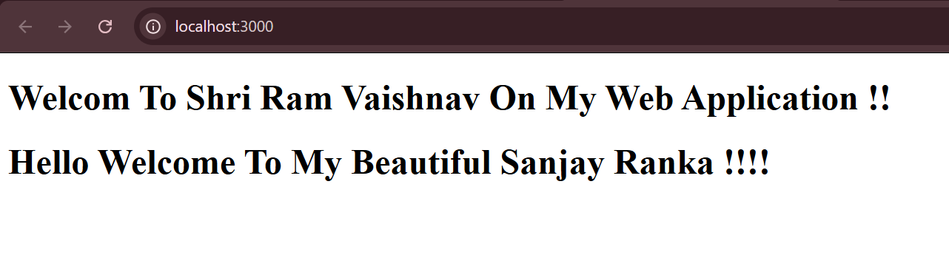

4.
Build a MiniProfile functional component that shows a user's display picture (use any image URL), name, and a short status message using JSX. Use this component to display your own mini profile like Instagram.

Ans.
